**HW4 Report**

**Math Problems:**

USE BROWSER: Google Chrome 53.0.2785.116.

Problems:

These problems were a lot harder and took a lot of time.

I didn’t know how to manipulate these matrices using the UTIL classes provided so I had to write a lot of helper functions. Some of them I found online.

Solutions:

I had to do a lot of testing to check if helper functions worked properly.

I had to look back at the lectures and class notes to solve each problem.

Question 4 was especially hard because at first I didn’t know how to calculate the up-vector. The teacher cleared my confusion in class.

**Coding Problems:**

USE BROWSER: Firefox 49.0.2

Just press the web-buttons to make the functions work. For rotation you can also use arrow-keys and A-W-S-D keys on the keyboard.

Problems:

Seeing the rotations was hard while the object was also rotating.

At first I had over-simplified the all the problems but my confusions were cleared after talking to a classmate.

Solutions:

I added an extra button for pausing the rotation to help see the button-rotation.

I had thought only a few lines of code needed to be added but my classmate pointed out that I was not computing things properly.

The following are my solutions after understanding how to properly think about the problems

2.1 – Input file format is already evaluated by given code.

To change to cow simply uncomment this line:

//var objName = 'cow.obj'; //uncomment this to toggle cow

To see the cow look at **Figure 4.**

To display cube uncomment the cube line:

var objName = 'mycube.obj'; //uncomment this to toggle cube

2.2 – object is already normalized to the origin in the given code

2.3 – The obj-loader.js file already computes the face-normal for each face. I added onto this code to get the average normal for the vertices. I tried many ways to compute the average normal in place before the face-normal was entered into the normal array but it is not possible. So, I ended up iterating through every vertex in the vertex array to check if the vertex was already entered then I added the normal to get the average and replaced both vertex normals with the average normal. **See Figure 1** for the code picture.

2.4 – I have made it so the user can use web-buttons, arrow keys and A-W-S-D keys to rotate the object. First to make the objet rotate I tried to multiply the mvMatrix in each rotate function but this did not work nicely. Then I found in drawScene after mvPushMatrix() call the angles were being computed so I put the following line after mvPushMAtrix() call:

mvMatrix.multiply(curRot);

Then web-buttons were already setup but for setting up the keyboard-buttons had to find the ASCII code for each key and also find how to process keyboard input. **See Figure 2** for code.

2.5 – Inverting normal did not make sense to me at first but after playing around with zoom-in/out I saw the object became black. Then I saw in initScene() function when we start reading the OBJ file with the readOBJFile() function we compute the Normals as “true”. So, I changed the variable invertNormals to a boolean. Then I copy pasted the start reading OBJ file code from initScene into the invertNormals() function. **See Figure 3** for code and result output. I was not able to find out how to find N, X, C for the computation of N dot (X – C).

Figure 1: Average normal code in obj-loader.js

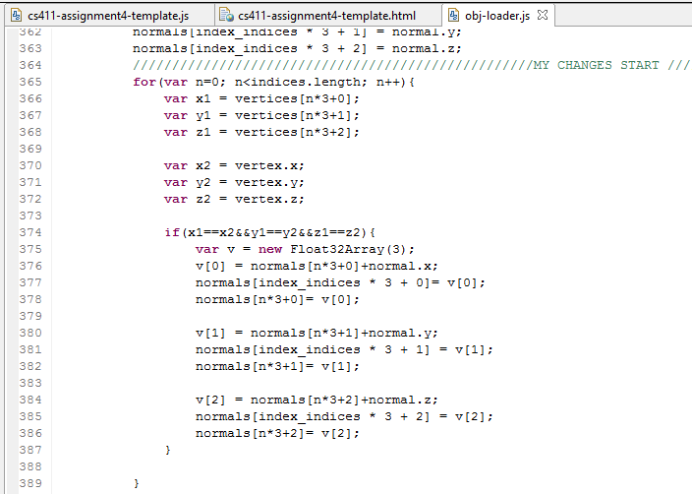 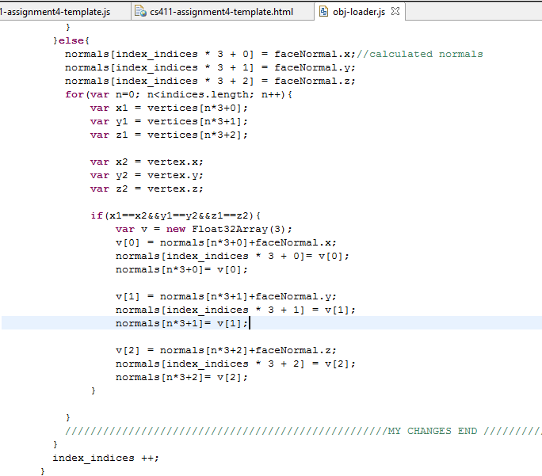

Figure 2: Button and keyboard code for rotation

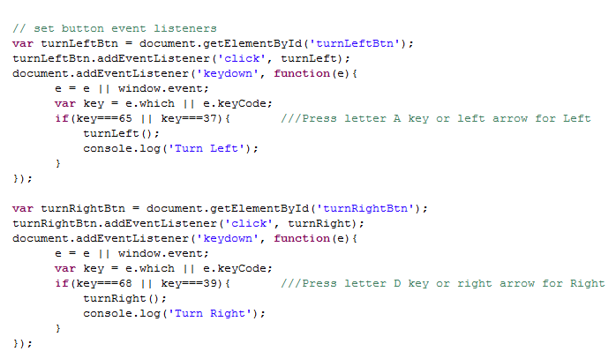

Figure 3: invertNormals code and output

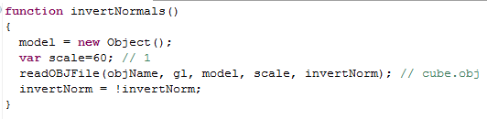

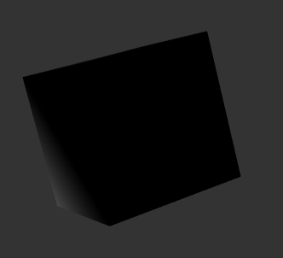 invertNormals=true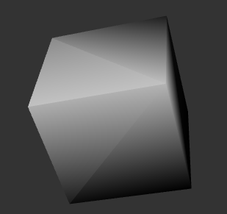 invertNormals=false

Figure 4: Cow

